Automotive Door Control System DesignPart 2Dynamic Design

**Name: Mohamed Abdelnasser Mehery**

**ECU 1**1- State Machine Diagram for each ECU1 Component  
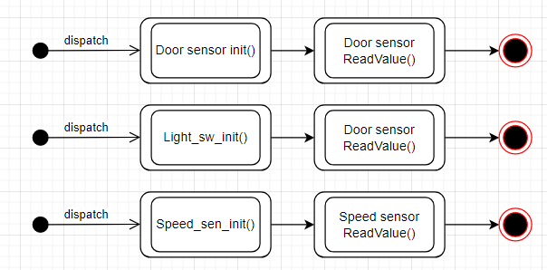

2- State Machine Diagram for ECU2 Operation

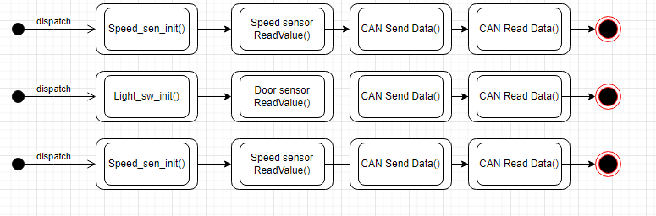

3- Sequence Diagram for ECU1  
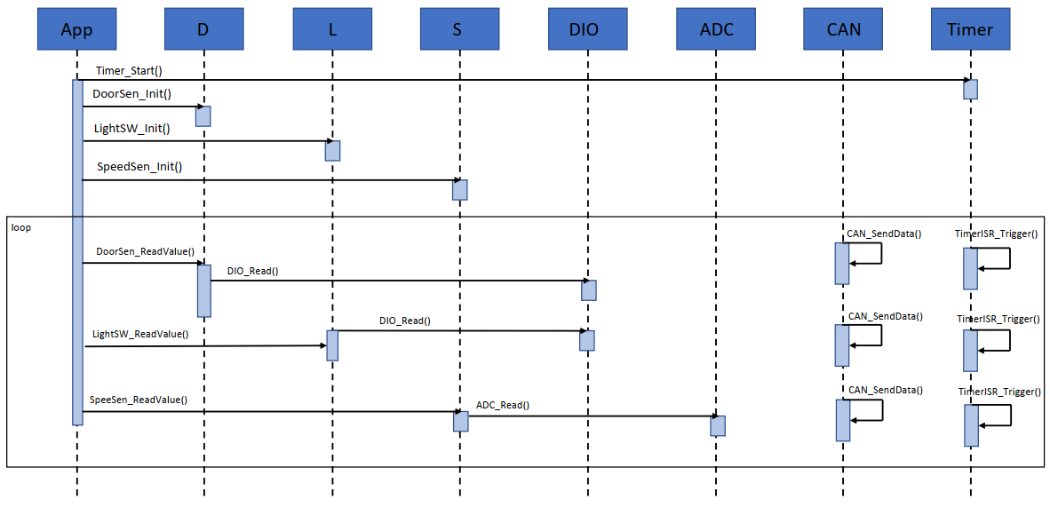

4- CPU load for ECU1

|  |  |  |  |
| --- | --- | --- | --- |
| SWC | period | Burst | Load % |
| Door state | 10 ms | 1ms | 10% |
| Switch state | 20 ms | 1ms | 5% |
| Car speed | 5 ms | 2ms | 40% |

Cpu load = 10 + 5 + 40 = 55%

**ECU 2**1- State Machine Diagram

1.1 Buzzer

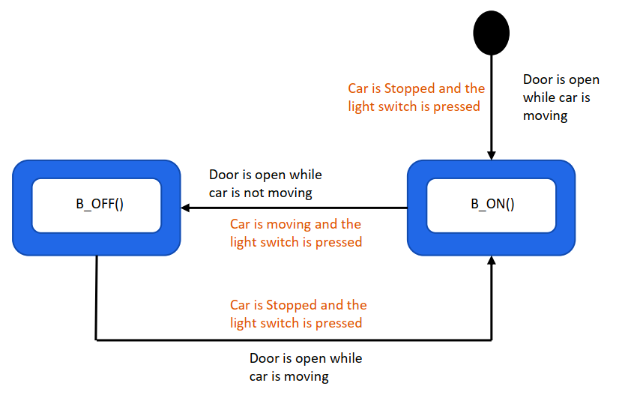

1.2 Light right (LR)

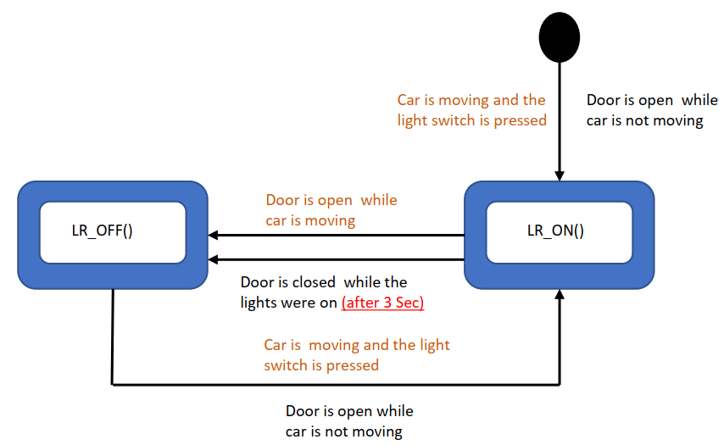

1.3 Left Light (LL)

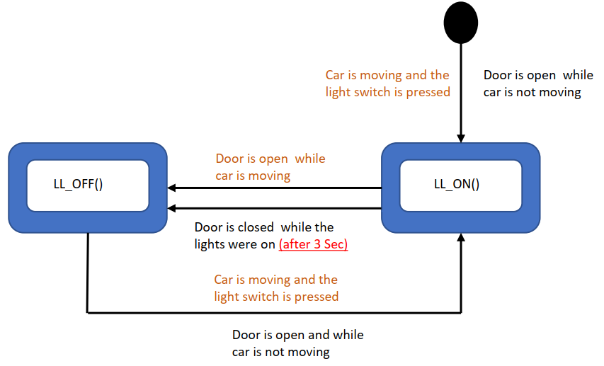

3- Sequence Diagram for ECU2

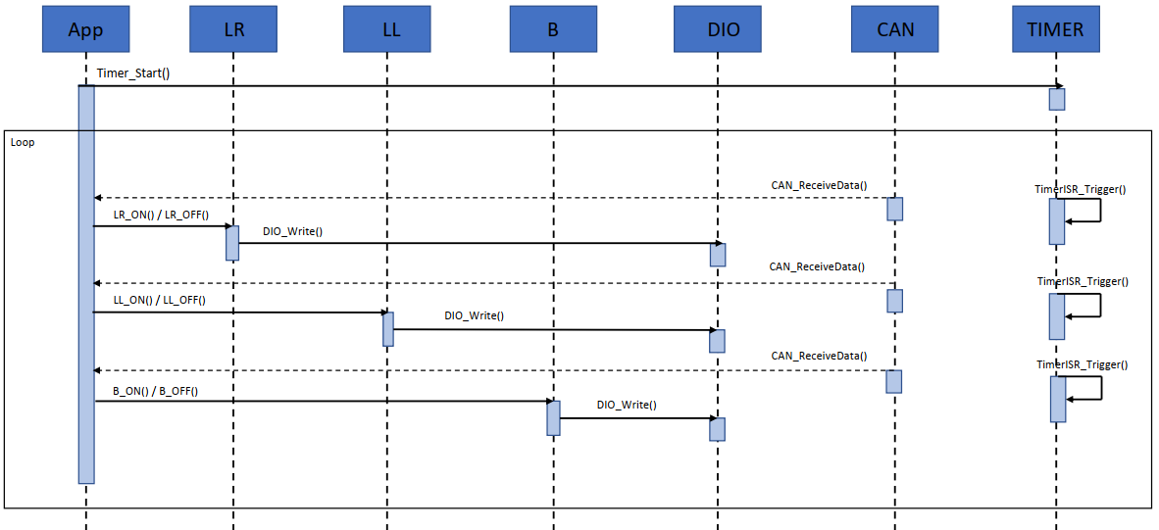

4- CPU load for ECU2

|  |  |  |  |
| --- | --- | --- | --- |
| SWC | period | Burst | Load % |
| Update Left light | 10 ms | 1ms | 10% |
| Update right light | 10 ms | 1ms | 10% |
| Update buzzer | 10 ms | 2ms | 20% |

Cpu load = 10 + 10 +20 = 40 %